CivicConnect | Ticket #103
Actual Supabase Studio screenshots
Evidence type: original user-supplied screenshots from the local Supabase SQL Editor. Images have not been recreated or altered. Screenshot captions identify the test and any limitations.

What these screenshots show
- Final request visibility: 5 of 5 role cases visibly pass.
- Final related-data tests: all six PASS rows visible directly in Supabase Studio, including Staff A and the direct-write privilege checks.
- Negative access tests: anonymous SELECT denied; cross-requester INSERT rejected; staff cannot UPDATE an unassigned request; requester cannot UPDATE a request.
- Some negative tests were photographed in an earlier sandbox session, before the final reset. They are supplementary, not proof of rerunning those exact negative cases after the reset.
- The clean migration reset passed in a sandbox with 12 audit triggers disabled because the upstream audit_row() function was missing. This limitation belongs in the issue documentation.
Screenshot update: The latest Supabase screenshot now displays all six PASS rows clearly, so the previous partial-results image has been replaced. The CSV is included only as supplementary evidence.

Evidence gallery
The following pages contain the original, unmodified Supabase screenshots. The PNG files are also available individually in the ZIP.

01 Test account setup
Five Supabase Auth accounts linked to requester, staff, manager and administrator profiles.
Test phase: Final setup | Source image: image(20261011-144313).png
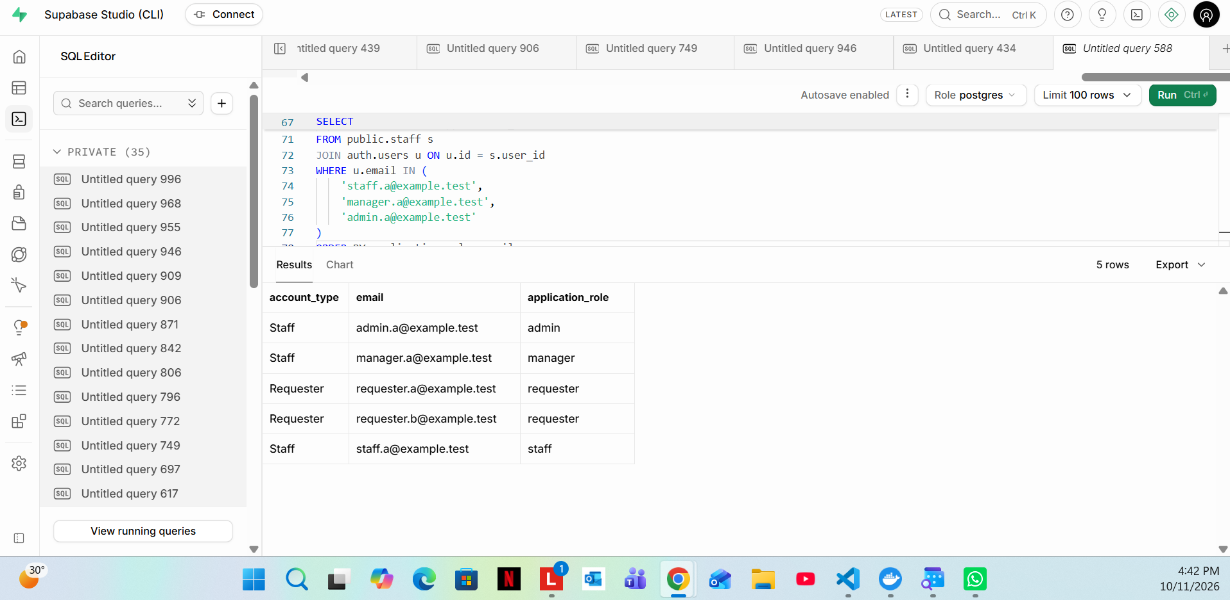

02 Test request fixtures
Two requests in Supabase: A owned by Requester A and assigned to Staff A; B owned by Requester B and unassigned.
Test phase: Final setup | Source image: image(20261011-144901).png
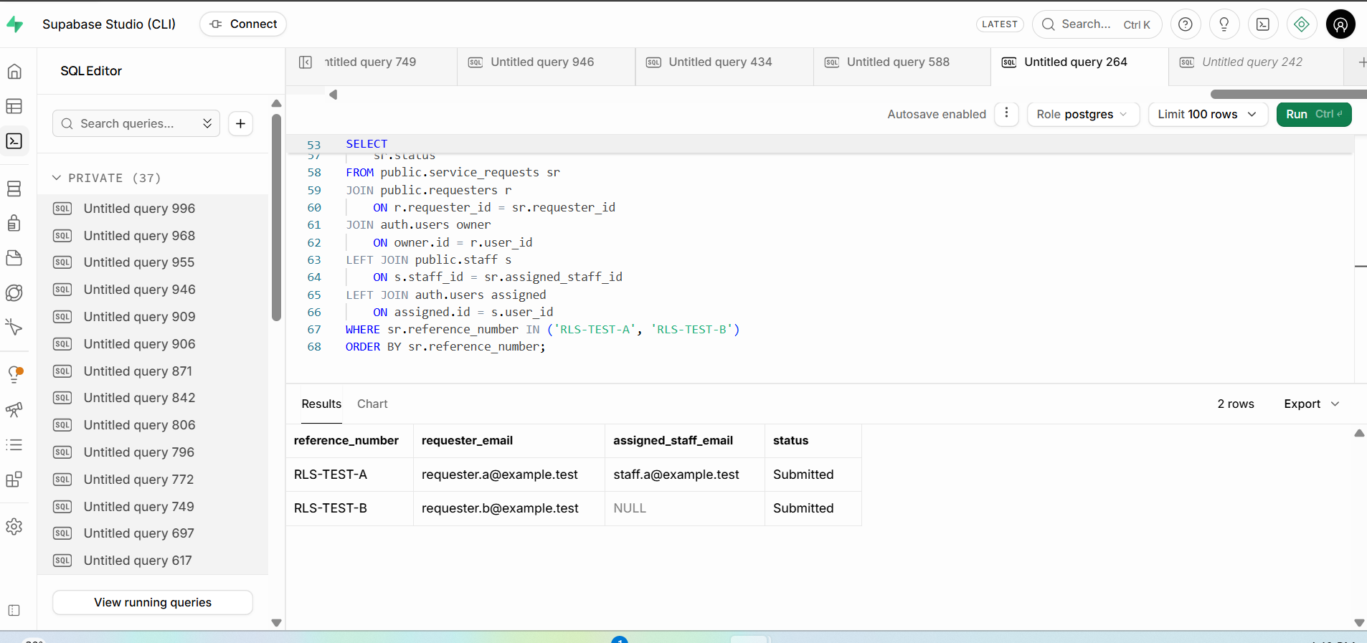

03 Service-request visibility: 5/5 PASS
The query result shows PASS for Requester A, Requester B, Staff A, Manager A and Administrator A.
Test phase: Final RLS migration | Source image: image(20261011-145255).png
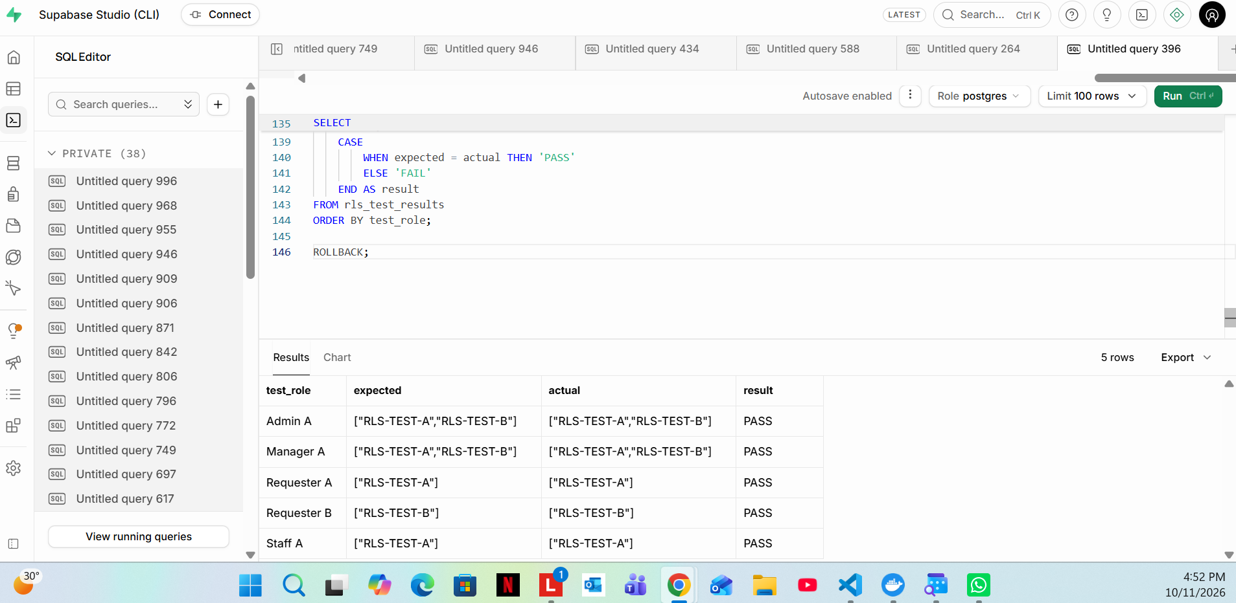

04 Protected-data visibility and write restrictions: 6/6 PASS
Final Supabase Studio screenshot shows six PASS rows, including Staff A, for comments, history, assignment and contact access plus direct-write privilege checks.
Test phase: Final RLS migration | Source image: image(20261011-151858).png
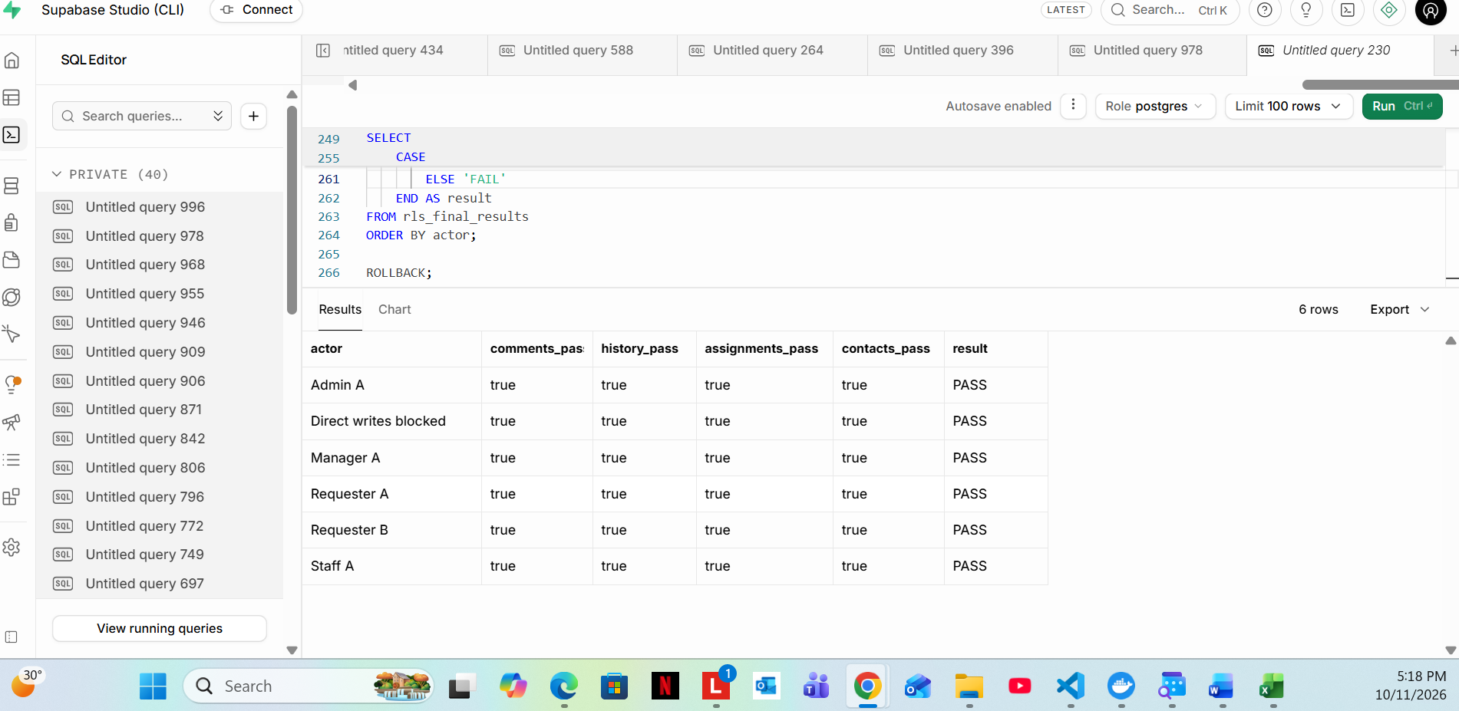

05 Negative test: anonymous request access denied
Earlier sandbox negative test screenshot: permission denied for service_requests (SQLSTATE 42501).
Test phase: Earlier policy testing | Source image: image(20261011-071154).png
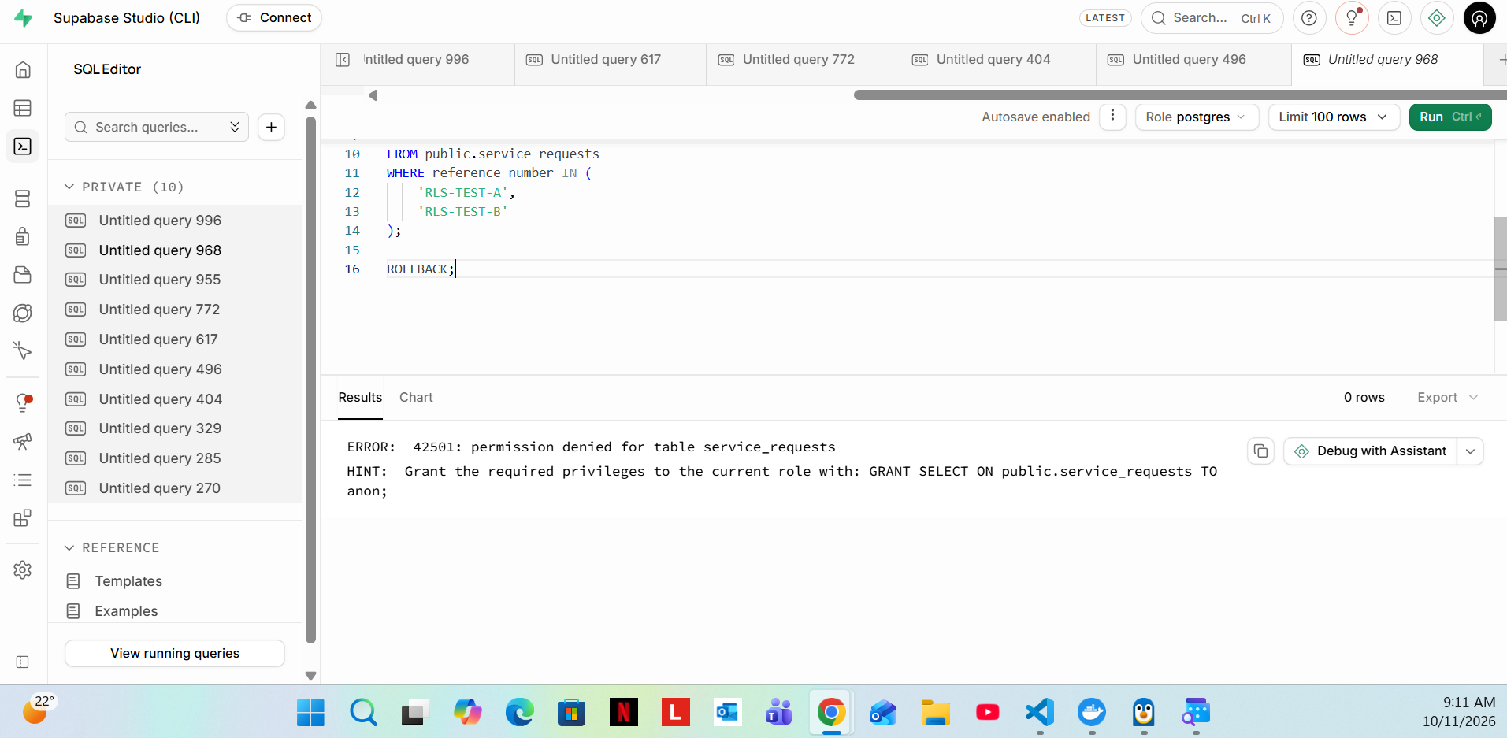

06 Negative test: impersonating another requester denied
Earlier sandbox negative test screenshot: Requester A attempting INSERT using Requester B ownership is rejected by RLS (SQLSTATE 42501).
Test phase: Earlier policy testing | Source image: image(20261011-073828).png
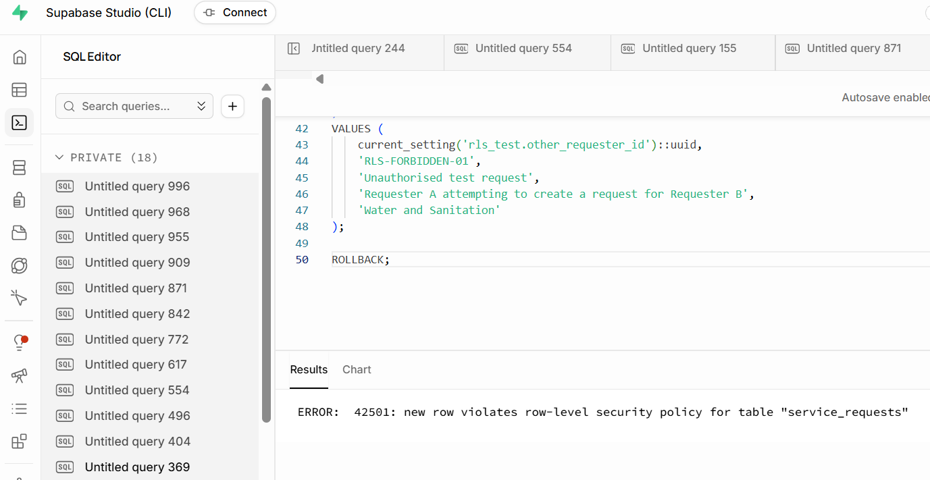

07 Scoped staff UPDATE test: assigned request
Earlier sandbox policy test (temporary UPDATE grant in rolled-back transaction) returned only assigned request RLS-TEST-A. This does not mean direct UPDATE is permanently granted.
Test phase: Earlier policy testing | Source image: image(20261011-075156).png
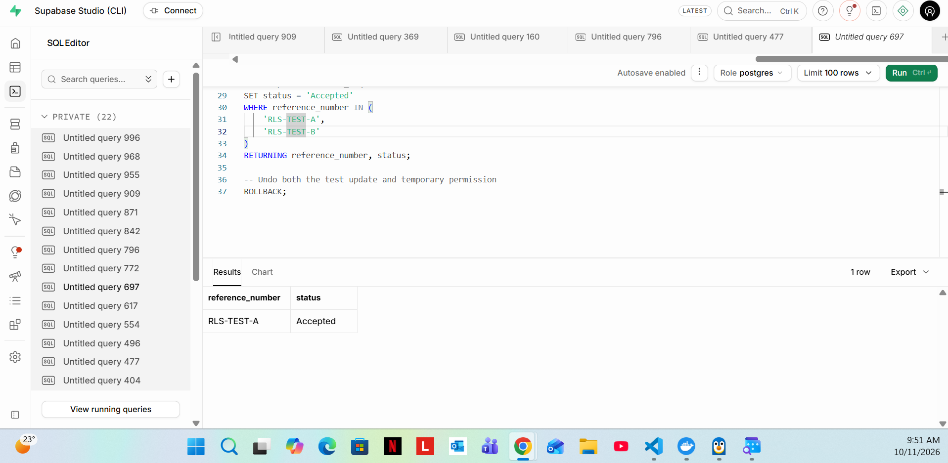

08 Negative staff UPDATE test: unassigned request
Earlier sandbox policy test with temporary grant returned updated_rows = 0 when Staff A attempted to update Request B.
Test phase: Earlier policy testing | Source image: image(20261011-075504).png
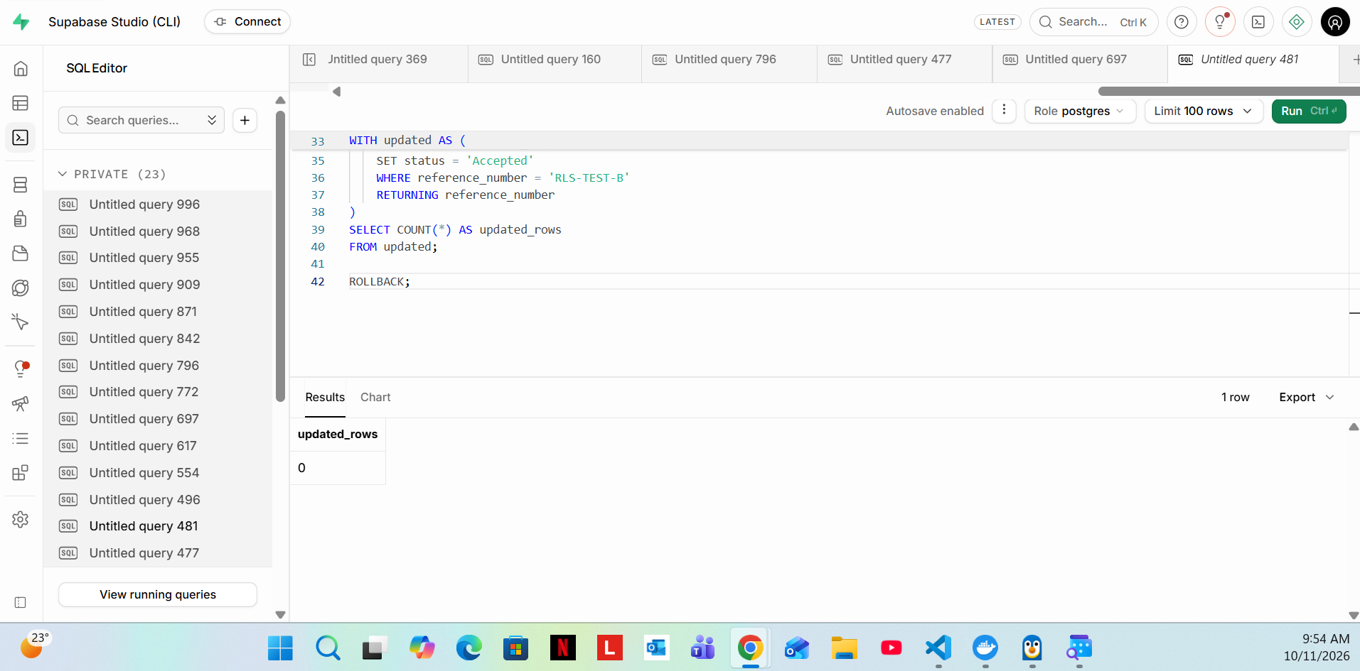

09 Negative requester UPDATE test
Earlier sandbox policy test returned updated_rows = 0 when a requester attempted status UPDATE; temporary grant was rolled back.
Test phase: Earlier policy testing | Source image: image(20261011-075643).png
